## Project one

## Wilkinson Power Divider

### B11102112 Chiajui Lee

## Schematic

### Schematic

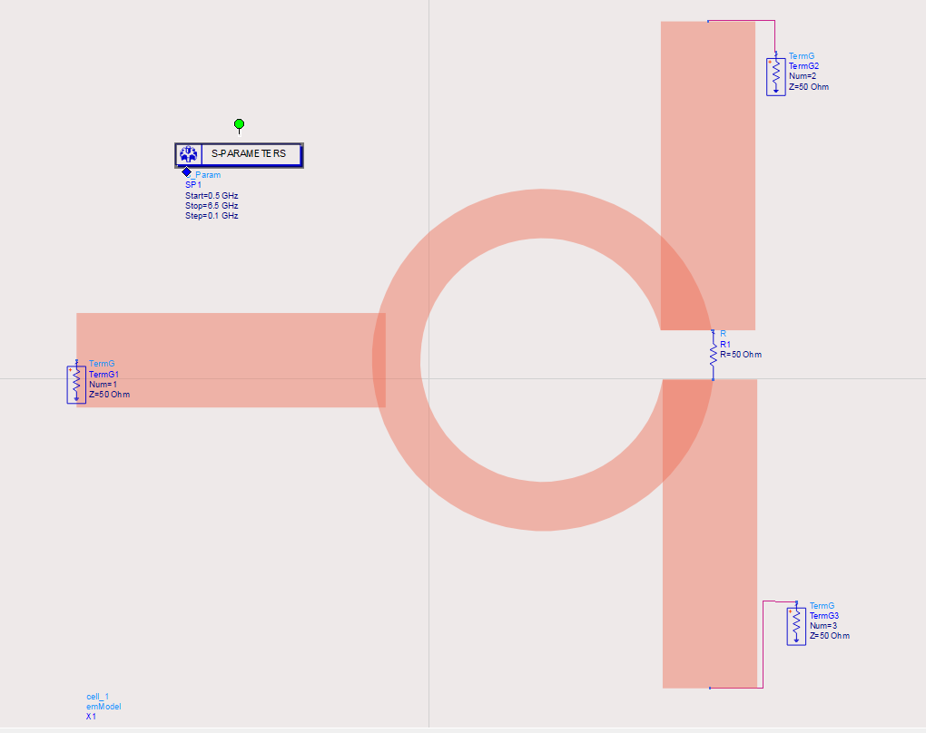

### Momentum

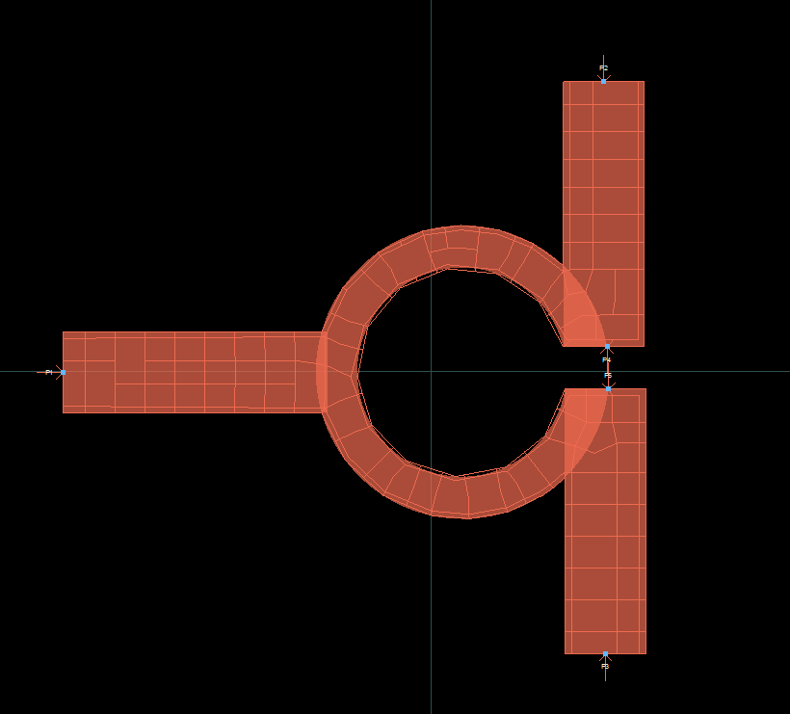

## Simulation results

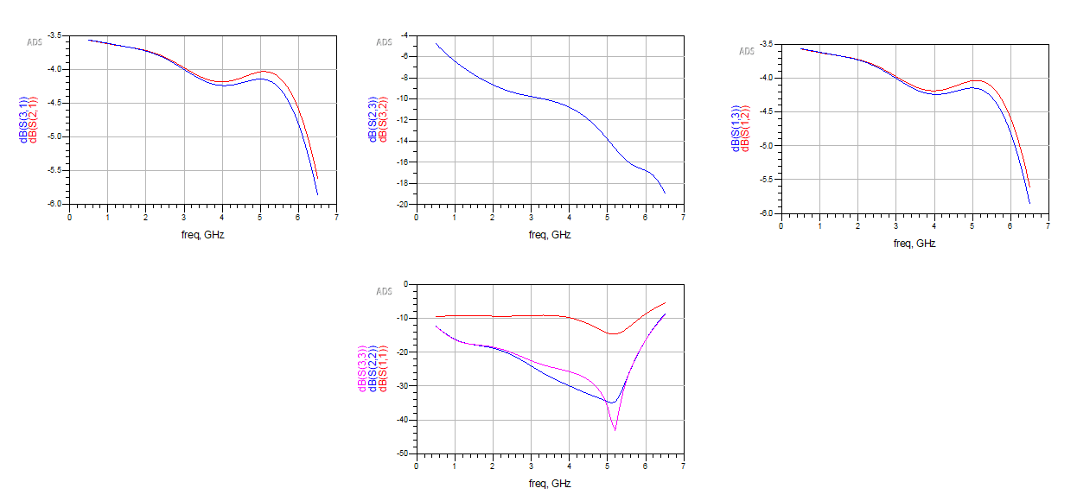

## Additional items

### Purpose

The Wilkinson Power Divider is a necessary component of our project to ensure uniform power division, high isolation between the output ports, and impedance matching, all of which are critical to guaranteeing signal integrity and efficient power transmission. The Wilkinson Power Divider is an essential component that will ensure that power is divided evenly between the two paths, preventing power imbalance. In addition to shunting power, the Wilkinson Power Divider will also increase the port isolation, ensuring that the communication signals and unwanted signals do not affect each other. The Wilkinson Power Divider is a critical component that will reduce the power loss on the divider, ensuring that the output signal is the same as the input signal.

### Principle

#### Even/Odd mode Analysis

##### Even mode

* Equal currents flow in **same direction** on two conductors.
* Fields are **symmetric** between conductors.

##### Odd mode

* Equal currents flow in **opposite directions**.
* Fields are **antisymmetric**, stronger coupling.

##### Superposition theorem analyze

$Positive terminal voltage: \frac{1}{2}V^{+}+\frac{1}{2}V^{-}=1V$

$Negative terminal voltage: \frac{1}{2}V^{+}-\frac{1}{2}V^{-}=0V$

##### Circuit characteristic

###### Even Mode Circuit Characteristics

* **Symmetry**: In even mode, the two conductors carry equal

currents in the **same direction**, resulting in a symmetric

field distribution.

* **Voltage**: The voltage between the two conductors is the same but with **opposite polarities** across the center of the conductors.

1. Odd Mode Circuit Characteristics

* **Asymmetry**: In odd mode, the two conductors carry equal currents in **opposite directions**, leading to an antisymmetric field distribution.
* **Voltage**: The voltage between the conductors is **opposite in polarity** at every point.